CSAU01 md record
wisis=urn:x-wmo:md:int.wmo.wis::CSAU01AMMC
urn:x-wmo:md:int.wmo.wis::CSAU01AMMC
ACCESS:
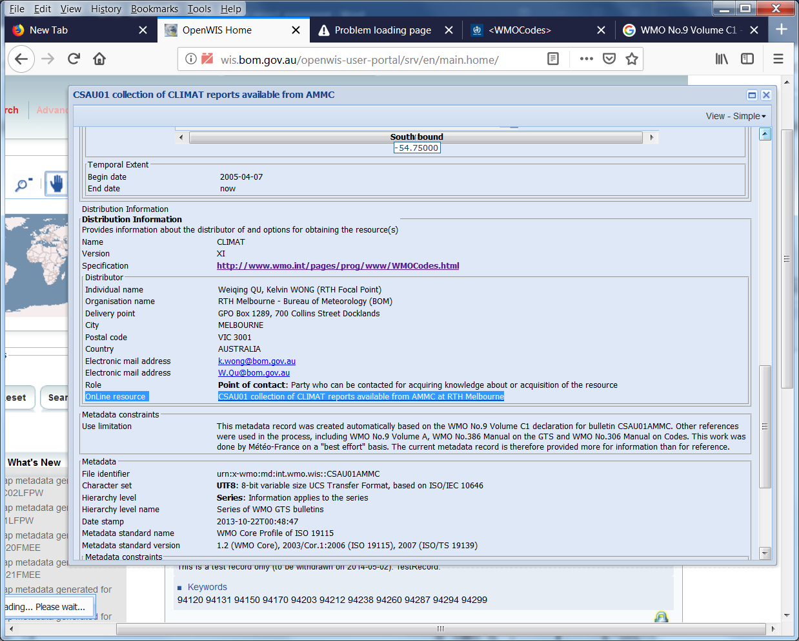
Temporal coverage of the data:
The record's TemporalExtent says 2005 onwards, whereas the date coverage of the data available in the cache is basically (at most) for the latest month, and as it is only retained for 24 hours, the date coverage is often nil.
Therefore, the temporal description should say something like:
"Latest month of data only. And that data is only available for 24 hours, after being released on 5th day of following month (GISC Cache Retention policy: 24 hours)".
And the start/end dates should say "now".

ASIDE:
Ideally, the record would also refer to sources where this same data is available longterm.
(NOAA ftp seems to retain it, as is, for a month; and ?? seems to retain it longer – tho it might be slightly different content).
These other "distributors" should ideally have a metadata record which refernces this CSAU01 WIS metadata record. And this WIS md record should indicate that.

SPATIAL extent for CSAU01:
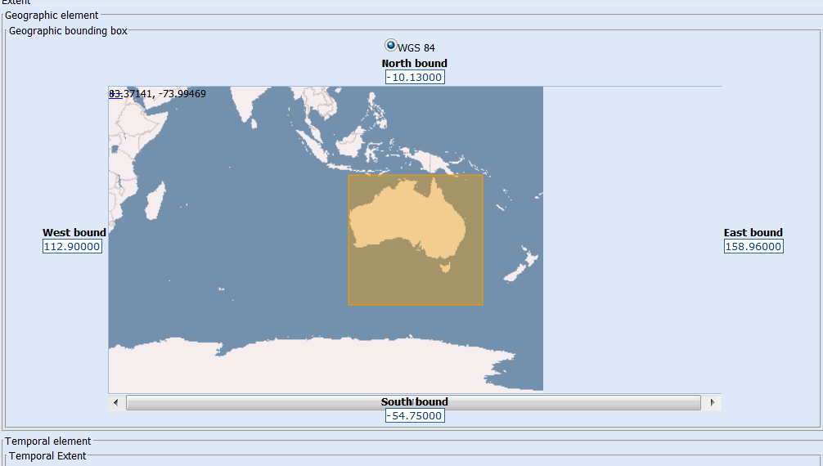
SPATIAL extent for CSAU02 :
Stations in abstract: Carnarvon airport, Learmonth airport, Port hedland airport, Newman aero, Alice springs airport, Mount isa aero, Richmond post office, Longreach aero, Mackay m.o, Rockhampton aero, Gladstone radar, Geraldton airport and Meekatharra airport
Keywd: 94300 , 94302 , 94312 , 94317 , 94326 , 94332 , 94340 , 94346 , 94367 , 94374 , 94380 , 94403 , 94430 (place)
BBOX should just be Queensland. False hits with single BBOX in metadata for point data
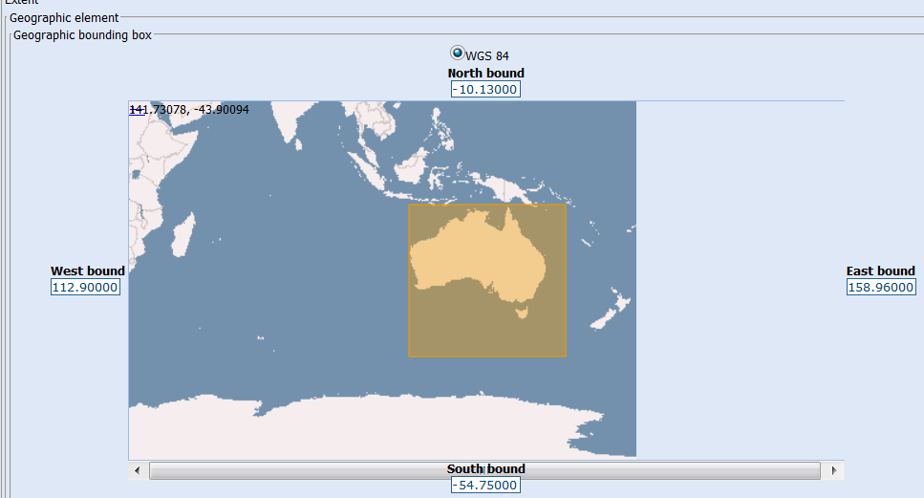
Data Access url: the Online Resource link is a deadlink. As this is a WMOEssential dataset, the user should be able to directly access it*.
I interpret 'WMOEssential' to mean ungated access to the data. However, it seems that WIS catalogues generally require users to register, for data access. Additionally, there appears to be a rule that direct access to the data from a record in a WIS catalogue, is theoretically limited to people (with an ?IP address) from that region?
If this is policy,
perhaps the md record should have urls saying:
- "Data access for WMO Region V (Australasia ..or another definition) users "
.. that takes a user to a login or registration page; and
- "Data access for users from other Regions"
… which takes users to a triage form …redirecting them to the relevant catalogue/etc

Abstract from metadata record
---- The bulletin collects CLIMAT reports:
FM 71 (CLIMAT, Report of monthly values from a land station).
(Refer to WMO No.306 - Manual on Codes for the definition of WMO international codes)
---- The CSAU01 TTAAii Data Designators decode (2) as:
T1 (C): Climatic data.
T2 (S): Monthly means (surface).
A1A2 (AU): Australia.
(2: Refer to WMO No.386 - Manual on the GTS - Attachment II.5)
---- The bulletin collects reports from stations:
Darwin airport, Tindal raaf, Gove airport, Weipa aero, Broome airport, Halls creek airport, Tennant creek airport, Burketown airport, Cairns aero, Townsville aero and Willis island

Based on the abstract, how evident is the content, to a novice user?
?What are the monthly values?
And is the fact that the data is encoded obvious?
The following references are included in the abstract, without an indication of what information will be delivered if accessed.
References without explanation of what it offers, nor url:
The record's abstract contains 2 references:
(Refer to WMO No.306 - Manual on Codes for the definition of WMO international codes)
(2: Refer to WMO No.386 - Manual on the GTS - Attachment II.5
No url is provided for the 2nd reference (tho the url is probably http://www.wmo.int/pages/prog/www/ois/Operational_Information/Publications/WMO_386/AHLsymbols/TableDefinitions.html ).
The url for WMO No. 306 is provided further down the metadata record, and goes to
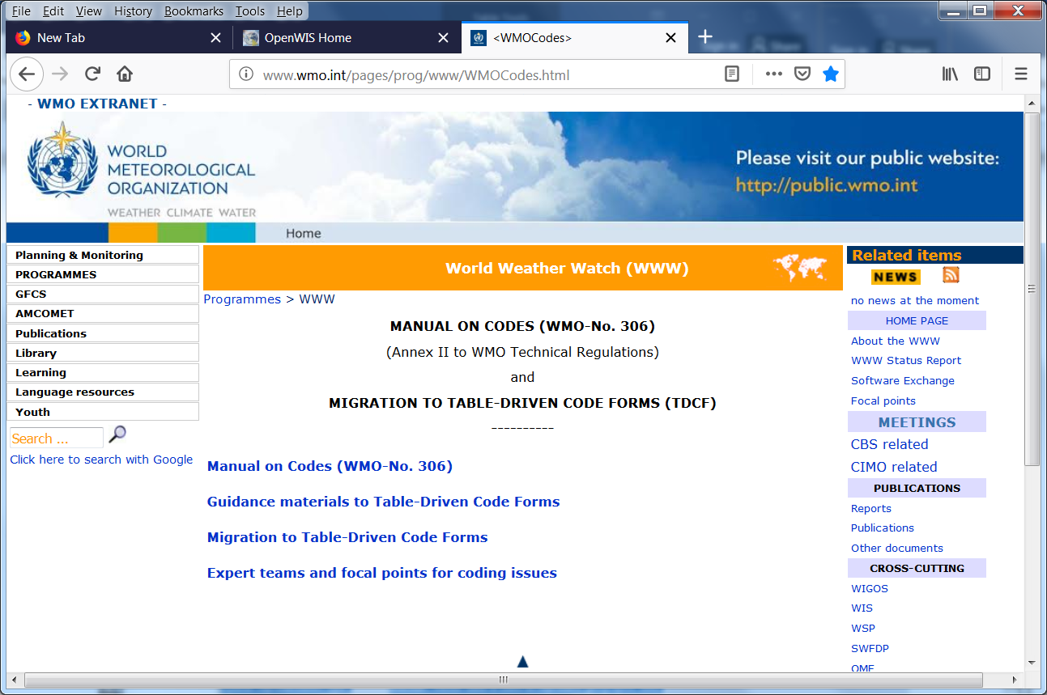
And the "Manual on codes" link goes to:
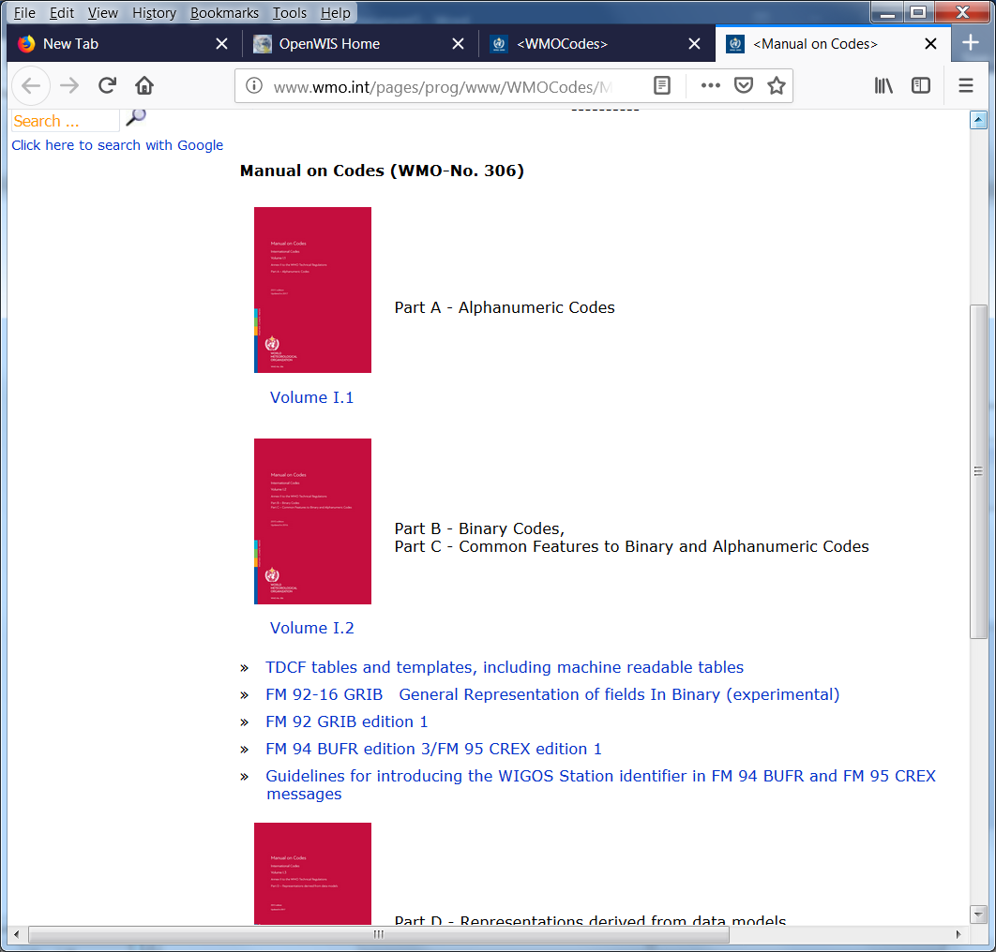
But its not stated in the metadata (and so wouldn’t be at all clear to the non-expert user) that FM-71 is an alphanumeric code.
It would be useful if this webpage indicated the FM codes included under Part A.
When you choose Part A, you then see:
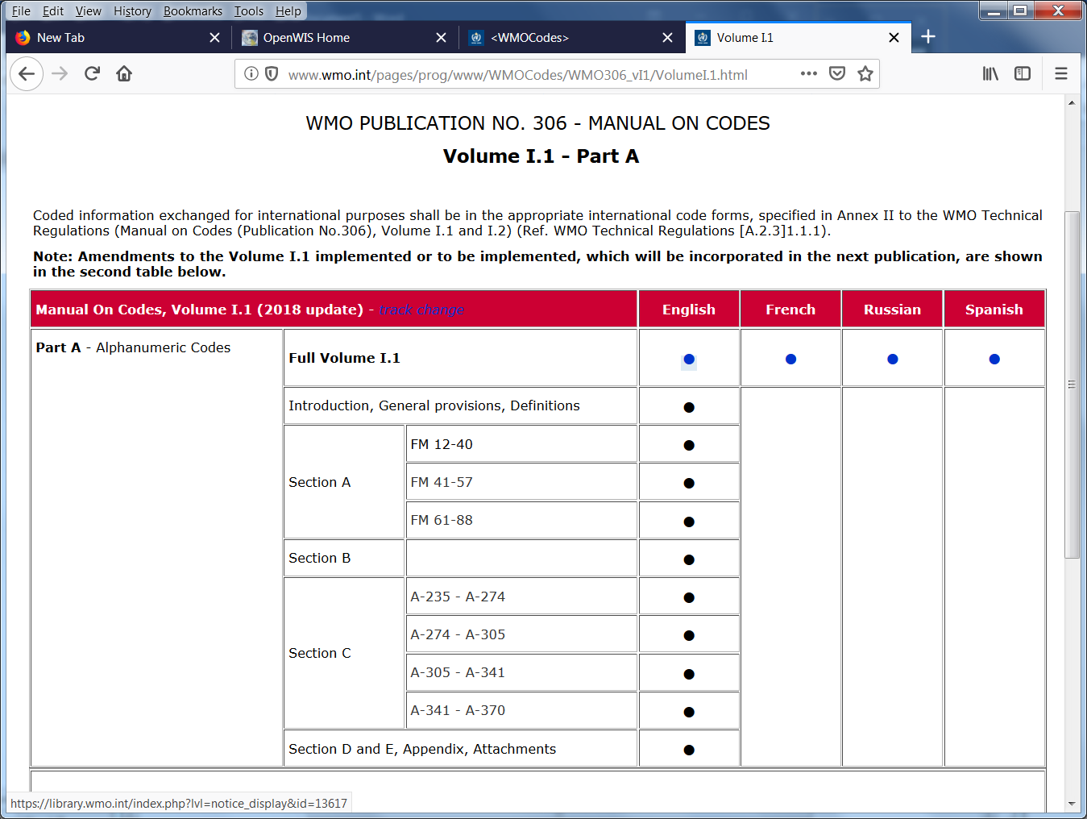
Again, the webpage design isn’t as userfriendly as it might be. For instance, the blue dots are live links, and the black dots are not. But you have try and try, to discover this.
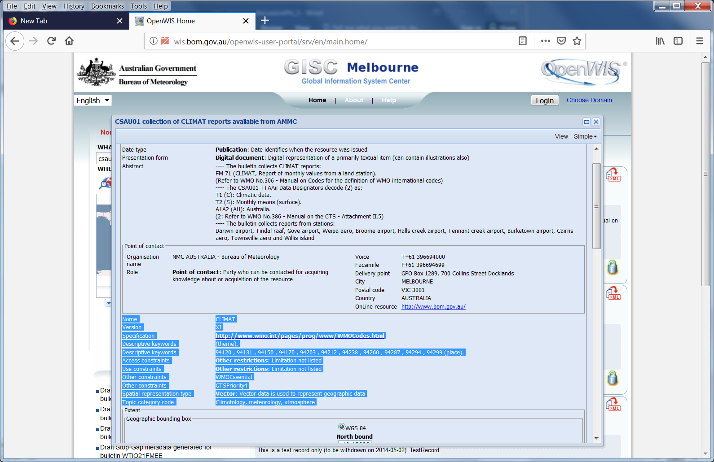
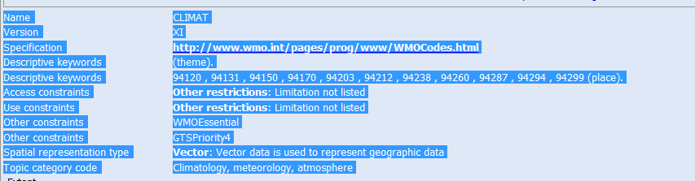
Eg
Name | CLIMAT
Version | XI
Specification | http://www.wmo.int/pages/prog/www/WMOCodes.html
Descriptive keywords | (theme).
Descriptive keywords | 94120 , 94131 , 94150 , 94170 , 94203 , 94212 , 94238 , 94260 , 94287 , 94294 , 94299 (place).
Access constraints | Other restrictions: Limitation not listed
Use constraints | Other restrictions: Limitation not listed
Other constraints | WMOEssential
Other constraints | GTSPriority4
Spatial representation type | Vector: Vector data is used to represent geographic data
Topic category code | Climatology, meteorology, atmosphere
The URL is for WMO Pub No 306 (which this section of the md record should say) http://www.wmo.int/pages/prog/www/ois/Operational_Information/VolC1_en.html
VolA is now in OSCAR : https://oscar.wmo.int/surface//index.html#/

In the MetadataConstraints/Use Limitations, it says:
Metadata constraints
Use limitation | This metadata record was created automatically based on the WMO No.9 Volume C1 declaration for bulletin CSAU01AMMC.  Other references were used in the process, including WMO No.9 Volume A, WMO No.386 Manual on the GTS and WMO No.306 Manual on Codes. This work was done by Météo-France on a "best effort" basis. The current metadata record is therefore provided more for information than for reference.

These references have no url. The actual url for Vol C1 is :http://www.wmo.int/pages/prog/www/ois/Operational_Information/VolC1_en.html and goes to:
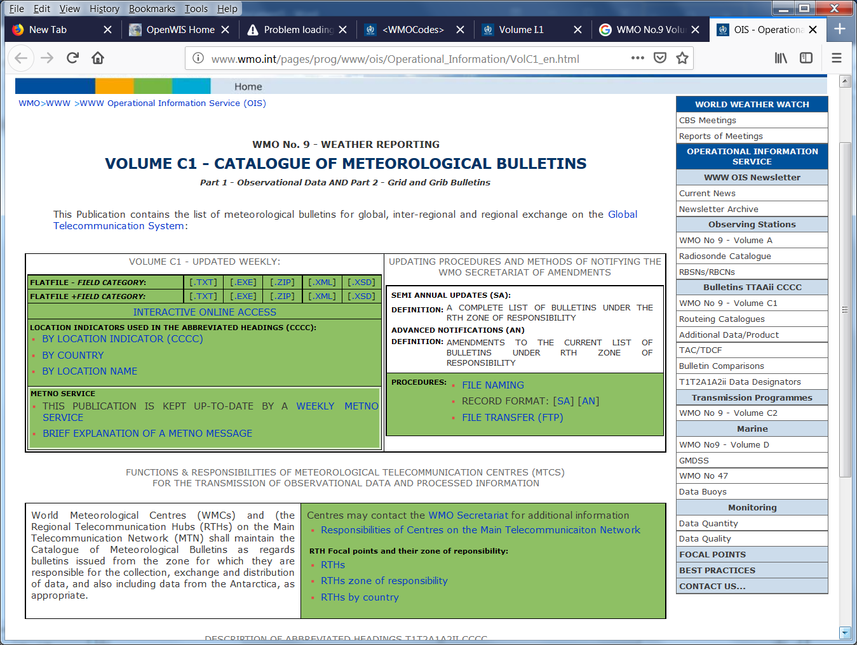

WMO No. 9, Vol A is also referred to without a URL. That url is : http://www.wmo.int/pages/prog/www/ois/volume-a/vola-home.htm and goes to
